**Instructions**

**I. Scenario**

Imagine you are a material scientist in an engineering firm. You specialize in designing mechanical metamaterials for high-strength light-weight components. To help you with your job, your firm recently acquired a decision support tool. Your job is to use this tool to create metamaterials with high strength and low weight. The best metamaterials among all metamaterials you create will help the firm determine how the tool improves overall performance. You will also complete a questionnaire assessing your knowledge of mechanical metamaterials before and after using the tool. Your goal is to *maximize the stiffness and minimize volume fraction of mechanical materials as much as possible.*

**II. Tool**

The tool focuses on a specific type of mechanical metamaterial that has following properties:

1. A unit structure repeats in a 2D plane to create a metamaterial, as seen from Fig. 1.
2. The unit structure is made of multiple links joining nodes in a 3 x 3 grid. Not all links are necessary.

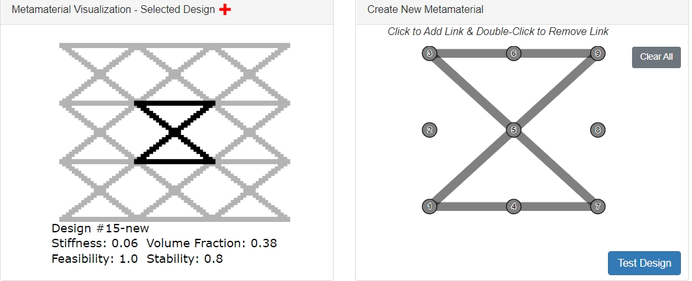

Fig. 1 Metamaterial design and a unit structure within it

1. Every metamaterial is rated using two objectives, *vertical* *stiffness* (relates to strength) and *volume fraction* (relates to weight)*.*

Additionally, there is a *feasibility* constraint that metamaterial should satisfy. Desired metamaterials maximize stiffness and minimize volume fraction. All metrics are normalized between 0 and 1.

|  |  |  |
| --- | --- | --- |
| Vertical stiffness | Relates to the amount of vertical force required to expand or contract a metamaterial by unit distance vertically | The larger the better |
| Volume fraction | The volume of unit structure divided by total volume (including missing links and empty space in the unit area) | The smaller the better |
| Feasibility | No two links should intersect, except at nodes. Also, metamaterial should be fully connected (i.e. cannot have disconnected subcomponents). | Equal to 1 is desired. Every violation of the constraint reduces feasibility by 0.1. |

The tool offers many functionalities.

1. You can explore a dataset of old metamaterials. Blue dotted line represents a set of best designs, also called the pareto front.



1. You can create your own metamaterial and evaluate its vertical stiffness and volume fraction. Your job is to create new designs that are among the best designs (belong to the pareto front), i.e., they either have higher stiffness or lower volume fraction than any other design in the dataset.



1. The tool offers an artificial intelligence (AI) agent to generate new metamaterial automatically. You can select values of features you like and the AI agent will generate a new metamaterial with those features. Each feature takes value between -2.5 (low) to 2.5 (high).



**III. Sample Questions**

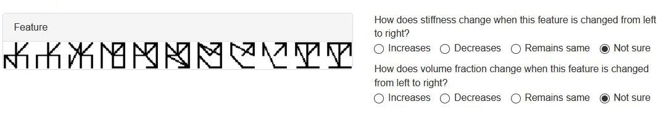

Sample question 1

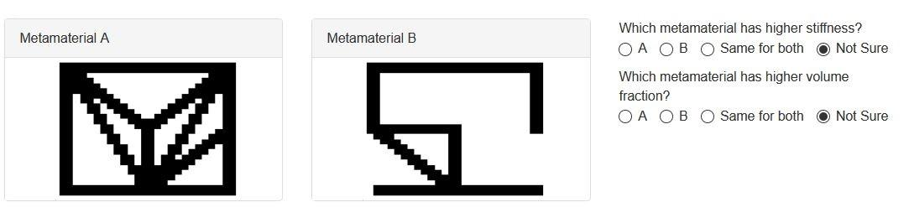

Sample question 2

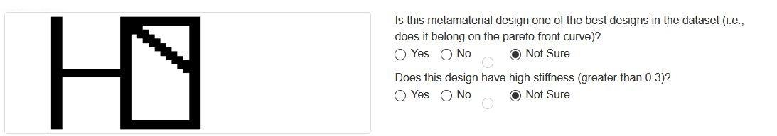

Sample question 3

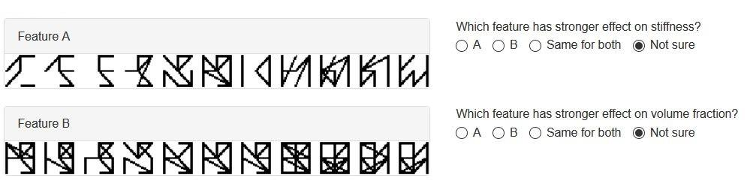

Sample question 4

**IV. Experiment Protocol**

|  |  |  |
| --- | --- | --- |
| **Part** | **Description** | **Approximate Time** |
| Instructions | Please read the instructions carefully. | 5 min |
| Pretest questionnaire | Answer 5 questions for assessing your prior knowledge of mechanical metamaterials | 2 min |
| Task 1 | Test tool functionalities such as exploration of old metamaterials and creation of new metamaterials | 15 min |
| Questionnaire 1 | Answer 12 questions for assessing new things you learned from Task 1 and functionalities within | 5 min |
| Task 2 | Test tool functionalities such as generation of new metamaterials using an AI agent | 15 min |
| Questionnaire 2 | Answer 10 questions for assessing new things you learned from Task 2 and functionalities within | 5 min |
| Survey | Complete a short survey about self-assessment of your knowledge | 2 min |
| Results | Review the performance of new metamaterials you created. Also, cross-check your responses to see how you performed on the questionnaire | -- |

Remember your goal is to maximize vertical stiffness and minimize volume fraction of mechanical materials as much as possible. Please utilize Task 1 and Task 2 to create as many best metamaterials (i.e., pareto front designs) as possible.